Joe Fanning

[joespirial@hotmail.com](mailto:joespirial@hotmail.com)

AI Diary

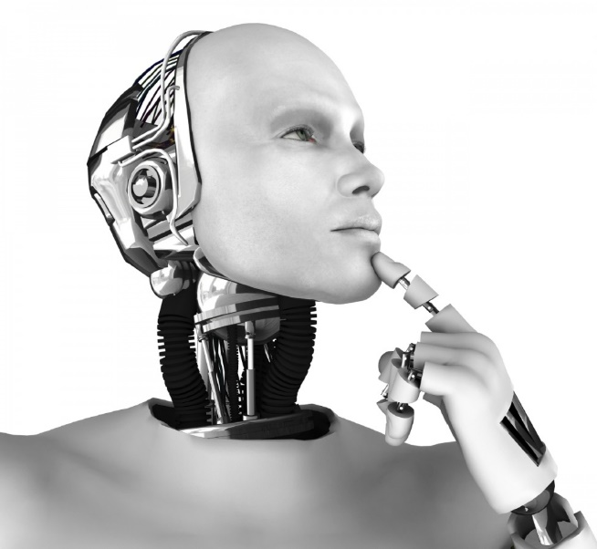

Project Technical Report

Contents

Executive Summary 5

1 Introduction 6

1.1 Background 6

1.2 Aims 7

1.3 Technologies 7

1.3.1 Programming Languages and Documentation: 7

1.3.2 Android: 8

1.3.3 Google Play Services: 8

1.3.4 IBM Cloud 8

2 System 10

2.1 Requirements 10

2.1.1 Functional requirements 10

2.1.1.1 List and description of functional requirements 10

2.1.1.2 Use Case Diagram 14

2.1.1.3 Use Cases 14

2.1.2 User requirements 22

2.1.3 Non-Functional Requirements 22

2.1.3.1 Performance/Response time requirement 22

2.1.3.2 Availability requirements 22

2.1.3.3 Recover requirement 22

2.1.3.4 Robustness requirement 22

2.1.3.5 Security requirements 22

2.1.3.6 Reusability requirements 23

2.1.3.7 Maintainability Requirements 23

2.2 Design and Architecture 23

2.2.1 System Architecture Diagram 23

2.2.1.1 Architectural components of the distributed system: 24

2.2.2 System Design Diagram 24

2.2.2.1 System design components 25

2.3 Implementation 25

2.3.1 Class Diagram 25

2.4 Testing 26

2.4.1 Clean and format code for testing 26

2.4.2 Testing activity 27

2.4.3 Testing dialogs 27

2.4.4 Reoccurring errors 28

2.5 Graphical User Interface (GUI) Layout 28

2.5.1 Wireframes 28

2.5.2 Screenshots of key screens and explanations. 34

2.5.2.1 Main activities 34

2.5.2.2 Sub activities 37

2.6 Customer testing 43

2.6.1 Usability test. 43

3 Conclusions 46

3.1 Coding with AsyncTask 46

3.2 U.I. Design features 46

3.3 Testing 46

4 Further Development or Research 47

4.1 Video diary 47

4.2 Developing the app for collecting data for further research. 47

4.3 Further education 47

5 References 48

5.1 Research links: 48

5.2 Researched literature: 50

5.3 Project images: 51

6 Appendix 53

6.1 Project Proposal 53

6.2 Project Plan 63

6.2.1 Project plan with Gannt chart 63

6.3 Monthly Journals 66

6.3.1 October daily journals 66

6.3.2 November daily journals 66

6.3.3 December daily journals 67

# Executive Summary

The main objective of this project is to collect data to aid in the development of (AGI) artificial general intelligence, especially in area of cognitive computing. There is no current mobile app on the market that request its users to disclose personal thoughts for analysis to study environmental stimulus on human psychology. This app will function as an everyday personal digital diary. All data from every downloaded app will be uploaded to a cloud server for the projects research and development over the next ten years. Participants downloading the app will agree to all their diary entries being used in this project. The app will have automated daily routines. Such routines will automatically record: the date of every diary entry, the location of every diary entry, the weather forecast at time of every diary entry and major news events on the day of every diary entry. All auto collected data will be used in correlation with diary entries data to study environmental stimulus on human psychology. The app will also provide the user with the functionality to analyze environmental stimulus on their own human psychology. When the user has entered several (or any number of) diary entries, they can analyze all these diary texts entries for environmental stimulus on their own human psychology. Hopefully this app will generate curiosity about the ability of computers to process data results on human psychology; especially how we are affected by our environment. Data collected over the years can be sold to companies like Google, IBM or Microsoft AI departments or used to create a research lab from this project.

# Introduction

This technical report is for the third semester final project for the Higher Diploma in Computer Science in Mobile Technologies in the National College of Ireland. All information in this document is on the Android mobile app called AI Diary.

## Background

With the new Spring of AI there is a burst of ongoing development around the world in computer science to develop more human like computers and general AI. Computing speed has always been important, but it seems as much now about replicating all diverse types of human brain and mind functions and behaviors. IBM Watson’s(https://commonweal/watson/products-services/) *Natural Language Understanding*, *Conversation* and *Personality* *Insights or* *Deepmind’s AlphaGo(*<https://deepmind.com/research/alphago/),DQN(https://deepmind.com/research/dqn/>*)* and *DNC(https://deepmind.com/research/dnc/)* are just a few examples. The development of AI. seems to be moving at a growing pace and is having a very positive effect on the world today.

Where will all this lead to?

It will inevitably lead to the creation of a computer brain that mimics a human brain. To develop an artificial computer brain with the similar capabilities as a human brain would mark the beginning of a very positive new era in computing.

And can I help in any way?

If or when this brain is created it will have to be able to think for itself, learn on its own (Deep Learning). It will have to have unconscious process just like a human brain and mind. When we learn we consciously collect information in our brain and also process it as unconscious process working in the background. This could be analogous to a daemon process in a computer. Every brain is different, every brain has and is experiencing a different life and sequence of events. So, every brain process and mind experience in an individual is in some way a different conscious and unconscious experience than every other individual.

With this in mind, what better way to understand these process/experiences than to collect numerous personal human thought processes and experiences from individual personal diaries. The AI. Diary app would do this.

The background idea of this project is to help gather information (data) that will hopefully aid in some way with the worldwide endeavor to create artificial intelligence. It would be very exciting to play some part in the process of collecting this data for future research and development.

## Aims

Build an easy to use digital diary Android app that:

* Provides the user with an easy to use digital diary.
* Provides speech to text and text to speech services.
* Provides the user with the current detailed weather information.
* Provides the user with their current location and location updates where the user is in motion.
* Provides the user with the top five current news articles with images.
* Provides the user with the functionality to analyze environmental stimulus on their own psychology. Diary entry text data and environmental data such as news, weather and location occurring at the time of the diary entry will be used to provide these results to the user.
* Collect all the data from all the apps that are being used over the years to aid in the development of (AGI) artificial general intelligence.

## Technologies

### Programming Languages and Documentation:

* Java Language (Java 8), XML and SQLite database were used in Android Studio.
* Java documentation:
* https://docs.oracle.com/javase/8/docs/
* https://docs.oracle.com/javase/8/docs/api/
* http://watson-developer-cloud.github.io/java-sdk/docs/java-sdk-4.0.0/overview-summary.html Android software and hardware
* SQLite documentation
* <https://developer.android.com/reference/android/database/sqlite/SQLiteDatabase.html>

### Android:

* Android Studio Developer Tool IDE
* Android Studio version 2.3
* Android SDK tool 26.0.2
* Android platform version 8.0 (O) revision 1
* Device testing will be carried out with:
* Huawei SCL -L01. Android version 5.1.1 (Phone version to be updated)
* Android emulator (Nexus 5X)

### Google Play Services:

* Google Maps:

<https://developers.google.com/maps/>

### IBM Cloud

* **Watson Services:**
  + Natural Language Understanding:
* Sentiment feature: <https://www.ibm.com/watson/developercloud/natural-language-understanding/api/v1/#sentiment> “Analyze the general sentiment of your content or analyze the sentiment toward specific target phrases found in the text.”
* Emotion feature:

<https://www.ibm.com/watson/developercloud/natural-language-understanding/api/v1/#emotion> “Detect emotion conveyed by the entire body of text, or by the context around target phrases specified in the targets parameter.”

* + Personality Insights:

https://www.ibm.com/watson/developercloud/personality-insights/api/v3/#introduction

“The IBM Watson™ Personality Insights service enables applications to derive insights from social media, enterprise data, or other digital communications. The service uses linguistic analytics to infer individuals' intrinsic personality characteristics, including Big Five, Needs, and Values, from digital communications such as email, text messages, tweets, and forum posts”

I will be using the **big5_*characteristic*** for Big Five personality dimensions, which are:

1. Openness
2. Conscientiousness
3. Extraversion
4. Agreeableness
5. Emotional range

Along with their each consecutive 5 Facets:

1. <https://console.bluemix.net/docs/services/personality-insights/openness.html#openness>
2. <https://console.bluemix.net/docs/services/personality-insights/conscientiousness.html#conscientiousness>
3. <https://console.bluemix.net/docs/services/personality-insights/extraversion.html#extraversion>
4. <https://console.bluemix.net/docs/services/personality-insights/agreeableness.html#agreeableness>
5. <https://console.bluemix.net/docs/services/personality-insights/emotional-range.html#emotionalRange>

# System

## Requirements

To be able to gather the requirements specification, I first had to study two disciplines. They were psychology (conscious and unconscious process and archetypes and the collective unconscious), and computer science (AI and cognitive computing). The purpose of this app is to gather information and data to help in the development of AI. It will also show how environmental effects on human psychology can be measured using Artificial intelligence and cognitive computing. Thus, all the requirements needed are based on these purposes.

This part of the document (2.1) describes the working system of the AI Diary app, and describes the functional and nonfunctional requirements.

### Functional requirements

When the user starts to use the system, it will display a home activity. The home activity will display the app image icon, todays date underneath the icon and three buttons. Button one will activate an activity for creating a new diary entry. Button two will activate an activity for creating a video diary entry, and button three will open a date picker activity to open an historical diary entry activity.

#### List and description of functional requirements

* **Create a text diary entry for today**.

Display for the user an activity for creating a diary entry, when the user selects the ‘WRITE DIARY’ button.

* **Use speech to text**

Display for the user a speech prompt dialog, when the user selects the SPEECH TO TEXT button.

* **Use text to speech**

Generate an audio output for the user of the text in the text field, if there is text in the text field, when the user selects the TEXT TO SPEECH button.

* **View today’s weather forecast and details**.

Allow the user to select a weather icon button on the create a diary entry activity. When the user presses this weather icon button display todays weather description with an icon image appropriate to that description*.* Further weather readings are also displayed underneath the weather description. These include temperature, wind speed, pressure, humidity, visibility, sunrise and sunset.

* **View today’s top news articles and images**.

Allow the user to select a news icon button on the create a diary entry activity. Display today’s top five news article with images for each article on a popup window activity, when the user presses this news icon button*.*

* **View current location co-ordinates**.

Display for the user a location icon button on the create a diary entry activity. Display to the user their current location, with location updates and a Google map marking the location on a popup activity window, when the user presses this location icon.

* **View a historical diary entry**

Display for the user a date picker when the user selects the FIND DIARY button on the Main activity, or the OPEN button on the diary entry activity, or the OPEN button on the historical diary entry activity.

Then display for the user the historical diary entry details on the historical diary entry activity.

* **View historical diary entry location**

Display for the user a location icon button on the historical diary entry activity. Display to the user their location co-ordinates for that historical date, and a Google map marking the location. Display this information on a popup activity window, when the user presses the location icon.

* **View historical diary entry news**

Allow the user to select a news icon button on the historical diary entry activity. Display the diaries five news article for that historical date on a popup window activity, when the user presses the news icon button.

* **View historical diary entry weather**

Allow the user to select a weather icon button on the historical diary entry activity. Display the diary entries historical weather description with an image appropriate to that description*.* Further historical weather readings are also displayed underneath the weather description. These include temperature, wind speed, pressure, humidity, visibility, sunrise and sunset. This will be displayed when the user presses on the weather icon button.

Allow the user to select an IBM Watson icon on the diary entry activity and the historical diary entry activity. Display a Watson Analysis activity with three buttons when the user presses the IBM Watson icon on the diary entry activity or the historical diary entry activity.

* **Analyze all diary entries and environmental data with Watson Natural Language Understanding**
* Allow the user to select a NATURAL LANGUAGE UNDERSTANDING button in the Watson analysis activity.
* Display a natural language understanding popup window activity with two buttons when the user presses the NATURAL LANGUAGE UNDERSTANDING button. The two buttons are EMOTIONAL CONTENT FOR ALL DIARIES button and SENTIMENT FOR ALL DIARIES button.
* Display for the user on the natural language understanding popup window activity; the Watson NLU Sentiment feature score for all the diary text entries. Display this when the SENTIMENT FOR ALL DIARIES button is pressed by the user.
* Display for the user on the natural language understanding popup window activity; the Watson NLU Emotion feature scores for all the diary text entries. Display this when the EMOTIONAL CONTENT FOR ALL DIARIES button is pressed by the user.
* **Analyze all diary entries with Watson Personality Insights**
* Allow the user to select a PERSONALITY INSIGHTS button in the Watson analysis activity.
* Display a personality insights popup window activity with six buttons when the user presses the PERSONALITY INSIGHTS button in the Watson analysis activity. The six buttons are one INFO button and five FACETS buttons.
* Display for the user a popup dialog explaining about personality insights and how the scores are evaluated, when the user presses the INFO button
* Display for the user on the personality insights popup window activity; the Watson Personality Insights five characteristic with their scores. Display underneath each characteristic and its score a FACETS button.
* Display for the user a facets popup window activity if any of the FACETS buttons are pressed. Each facets popup window will display the five facets and their scores for their respective characteristic.

**View environmental effects on all diary entries.**

* Allow the user to select an ENVIRONMRNTAL EFFECTS ON PSYCHOLOGY button in the Watson analysis activity.
* Display for the user an environmental effects popup window activity with the Watson NLU Emotion feature scores for all the diary text entries displayed. Also display a COMPARE ENVIRONMENTAL SCORES button on the environmental effects popup window activity.
* Display for the user, all the Watson NLU Emotion scores for all diary entries, and all the Watson NLU Emotion scores for all the weather and news data on the environmental effects popup window activity, at the same time for comparison. This is all displayed when the user presses the COMPARE ENVIRONMENTAL SCORES button.

Note:All popup windows in the system will have a X button for closing.

#### Use Case Diagram

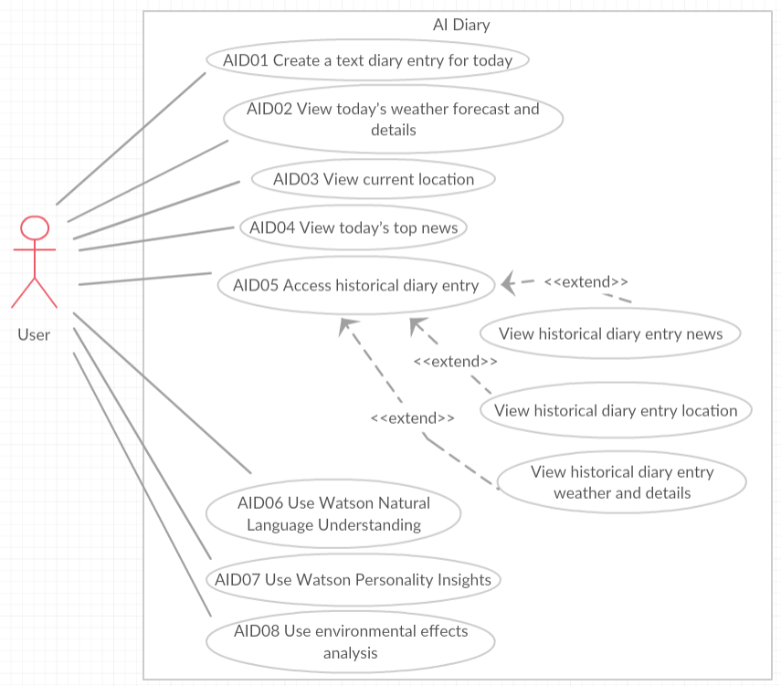

#### Use Cases

|  |  |
| --- | --- |
| **Use case ID** | AID01 |
| **Use Case Name** | Create a text diary entry for today |
| **Actors** | User |
| **Description** | User creates a textual or voice diary entry for today, and then presses save button. |
| **Preconditions** | The user must be connected to the internet. The user must press the DIARY ENTRY button on the main activity, which will open the diary entry activity which is where the user can enter their diary entry. |
| **Post conditions** | The application will save the diary entry to the database. The application will also save weather, news and location data to the database in a background process.  Display a Toast telling the user the diary entry has been saved |
| **Normal Flow** | The user enters the diary entry into the text field.  Then the user presses the save button to save the diary entry to the database. All the weather, news and location data are automatically saved when the user presses the save button. |
| **Exceptions** | 1-The user tries to save an empty text field.   * A dialog is displayed to enter text and the user enters text into the text field.   2-There is no internet connection to connect to the weather news or location APIs.   * A dialog is displayed to try connecting to the internet again and the user connects to the internet. |

|  |  |
| --- | --- |
| **Use case ID** | AID02 |
| **Use Case Name** | View today’s weather forecast and details |
| **Actors** | User |
| **Description** | The user opens a popup window activity on the diary entry activity to view all the weather information for today. |
| **Preconditions** | The user must be connected to the internet. The user must already be on the diary entry activity and must press the weather icon to open the weather popup window activity. |
| **Post conditions** | All the todays weather details from the weather API are displayed on the weather popup window activity. |
| **Normal Flow** | The user presses the weather icon on the diary entry activity and a popup window activity is displayed with all todays weather detail from the weather API. |
| **Exceptions** | 1 - No internet connection available for the weather API.  - A dialog is displayed to try connecting to the internet again and the user connects to the internet. |

|  |  |
| --- | --- |
| **Use case ID** | AID03 |
| **Use Case Name** | View current location |
| **Actors** | User |
| **Description** | The user views a location popup window activity with a Google map with a marker showing their location. The user can also view their location co – coordinates with location updates and location updates time. |
| **Preconditions** | The user must be connected to the internet and have location services turned on. The user must already be on the diary entry activity and must press the location icon to open the location popup window activity. |
| **Post conditions** | The Google map with location marker is displayed on a locations popup widow activity. The location co-ordinates are displayed below the map, with location update showing every few seconds. The location update times are displayed above the map |
| **Normal Flow** | The user presses the location icon on the diary entry activity and a popup window activity is displayed with the location details and a Google map with marker. |
| **Exceptions** | 1 - No internet connection available for the Google Maps API.  - A dialog is displayed to try connecting to the internet again and the user connects to the internet. |

|  |  |
| --- | --- |
| **Use case ID** | AID04 |
| **Use Case Name** | View today’s top news |
| **Actors** | User |
| **Description** | The user opens a popup window activity on the diary entry activity to view all the news information for today from the news API. |
| **Preconditions** | The user must be connected to the internet. The user must already be on the diary entry activity and must press the news icon to open the news popup window activity. |
| **Post conditions** | Five of today’s news articles with images from the news API are displayed on the news popup window activity. |
| **Normal Flow** | The user presses the news icon on the diary entry activity and a news popup window activity is displayed with five of today’s top news articles with images from the news API. |
| **Exceptions** | 1 - No internet connection available for the news API.  - A dialog is displayed to try connecting to the internet again and the user connects to the internet. |

|  |  |
| --- | --- |
| **Use case ID** | AID05 |
| **Use Case Name** | Access historical diary entry. |
| **Actors** | User |
| **Description** | The user views a historical diary entry, with access to historical news, weather and location for that historical date. |
| **Preconditions** | The user must press the FIND DIARY button on the main activity or the OPEN button on the diary entry activity or the Historical diary entry activity. Then a date picker is displayed. The user must select a date which will display the historical diary entry activity for that date. |
| **Post conditions** | The historical diary entry text is displayed to the user on the historical diary entry activity. There is also access to historical news, weather and location and Watson services available on the activity. |
| **Normal Flow** | The user presses the FIND DIARY button on the main activity or the OPEN button on the diary entry activity or the Historical diary entry activity. Then a date picker is displayed. The user selects a date from the date picker which will display the historical diary entry activity for that date. |
| **Exceptions** | 1 – There has been no diary entry for the date requested.   * A message is displayed in the text field of the historical diary entry activity to say that there has been no diary entry for this date. The weather news and locations data are empty. |

|  |  |
| --- | --- |
| **Use case ID** | AID06 |
| **Use Case Name** | View Watson Natural Language Understanding |
| **Actors** | User |
| **Description** | View the Watson Natural Language Understanding Sentiment feature scores and the Emotion feature scores for all the user’s diary text entries. |
| **Preconditions** | The user must press the Watson AI Analytics icon on the diary entry activity or the Historical diary entry activity. The user will then be brought to the Watson analytics activity where they will select the NATURAL LANGUAGE UNDERSTANDING button. When they press this button, they will open the Watson natural language understanding popup window activity. This activity has two buttons: EMOTIONAL CONTENT FOR ALL DIARIES and SENTIMENT FOR ALL DIARIES. This is where the user must run the Natural Language Understanding analysis for all their text diary entries. |
| **Post conditions** | The Natural Language Understanding Sentiment feature score and Emotion feature scores have been displayed to the user for all their diary text entries. All these scores are displayed on the natural language understanding activity. A message is displayed to say the Watson results have been analysed successfully. |
| **Normal Flow** | The user presses the Watson AI Analytics icon on the diary entry activity or the Historical diary entry activity. The user will then be brought to the Watson analytics activity where they will select the NATURAL LANGUAGE UNDERSTANDING button. When they press this button, they will open the Watson natural language understanding popup window activity. This activity has two buttons: EMOTIONAL CONTENT FOR ALL DIARIES and SENTIMENT FOR ALL DIARIES. The user presses the EMOTIONAL CONTENT FOR ALL DIARIES button, five emotions with scores are displayed for all the text diary entries. The user presses the SENTIMENT FOR ALL DIARIES button and the sentiment score is displayed for all diary entries. |
| **Exceptions** | 1 – There is a delay in the Watson API data results being received.   * Display a message to the user saying, ‘Please wait while the data is being analysed’.   2 - No internet connection available for Watson API.  - A dialog is displayed to try connecting to the internet again and the user connects to the internet. |

|  |  |
| --- | --- |
| **Use case ID** | AID07 |
| **Use Case Name** | Use Watson Personality Insight |
| **Actors** | User |
| **Description** | View the Watson Personality Insights five characteristic Trait scores and the twenty-five Facet scores for all the user’s diary text entries. |
| **Preconditions** | The user must press the Watson AI Analytics icon on the diary entry activity or the Historical diary entry activity. The user will then be brought to the Watson analytics activity where they will select the PERSONALITY INSIGHTS button. They must press this button, this will open the Watson personality insights popup window activity. This is where the user must run the personality insight analysis for all their text diary entries. |
| **Post conditions** | The application displays all the personality insights five characteristic trait scores and can also display the twenty-five facet scores for each characteristic trait. |
| **Normal Flow** | The user presses the Watson AI Analytics icon on the diary entry activity or the Historical diary entry activity. The user will then be brought to the Watson analytics activity where they will select the PERSONALITY INSIGHTS button. The user presses this button, this will open the Watson personality insights popup window activity. This activity has six buttons. Button one is the INFO button. The user will press this button to displays information about the personality insights scoring details. There is also five FACETS button, one for each characteristic trait, the user will press each FACETS button, each will display a facets popup window activity that displays five characteristic facets and their scores about that characteristic trait. |
| **Exceptions** | 1 – There is a delay in the Watson API data results being received.   * Display a message to the user saying, ‘Please wait while the data is being analysed’.   2 - No internet connection available for Watson API.  - A dialog is displayed to try connecting to the internet again and the user connects to the internet. |

|  |  |
| --- | --- |
| **Use case ID** | AID08 |
| **Use Case Name** | Use environment effects analysis |
| **Actors** | User |
| **Description** | The user analyses environmental effects on their own psychology by comparing all their diary entry emotion scores with all the weather and news emotion scores. |
| **Preconditions** | The user must press the Watson AI Analytics icon on the diary entry activity or the Historical diary entry activity. The user will then be brought to the Watson analytics activity where they will select the ENVIRONMENTAL EFFECTS ON PSYCHOLOGY button. The user presses this button, they will open the environmental effects on psychology popup window activity. This is where the user must run the environmental effects on psychology for all their text diary entries. |
| **Post conditions** | The application displays all the five emotion scores for all diary entries and displays all the emotion scores for all the weather and news data, so scores can be compared. |
| **Normal Flow** | The user presses the Watson AI Analytics icon on the diary entry activity or the historical diary entry activity. The user will then be brought to the Watson analytics activity where they will select the ENVIRONMENTAL EFFECTS ON PSYCHOLOGY button. When they press this button, they will open the environmental effects on psychology popup window activity. This activity is displaying all the emotion scores for all the diary entries. This activity has one button: COMPARE ENVIRONMENTAL SCORES. The user presses the button and the emotion scores are displayed for all the weather and news data. The user can now compare these score with the emotion score for all diary entries. |
| **Exceptions** | 1 – There is a delay in the Watson API data results being received.   * Display a message to the user saying, ‘Please wait while the data is being analysed’.   2 - No internet connection available for Watson API.  - A dialog is displayed to try connecting to the internet again and the user connects to the internet. |

### User requirements

The user will require an Android device and a Google account to download and use the app. The user will also require access to the internet with sufficient internet connection coverage and broadband speed.

It is required by the user to understand and agree that all their personal diary entry data and environmental data will be used to help in the research and study of Artificial Intelligence.

### Non-Functional Requirements

#### Performance/Response time requirement

This system uses connections to the internet where data is analysed on remote server APIs and returned to the system for users to view. It is required that these APIs respond to the system without noticeable delay.

#### Availability requirements

This system uses connections to the internet where data is analysed on remote server APIs and returned to the system for users to view. It is required that these APIs can be connected to at all times; day and night and throughout the year.

#### Recover requirement

This system stores user’s data in a database. It is required that this data is also stored in a backup file location, so if the database is corrupt or lost, the backup data can be reinstalled to a new database.

#### Robustness requirement

It is required to the best of the system’s ability to recover from all internal system errors and external errors (such as API errors) so the user can continue to use the system without the system failing.

#### Security requirements

It is required by the user to understand and agree that all their personal diary entry data and environmental data will be used to help in the research and study of Artificial Intelligence. However, it is required that the identity of the user is always protected by the system.

#### Reusability requirements

It is required the system is designed so reusability can be applied. The main code will apply **code reuse** and **modularity** wherever possible, and so will the design layout.

#### Maintainability Requirements

The system should be easy to maintain. All code should be commented for logical understanding and all design and functional logic should be documented. This is required so the system is easy to maintain from a diagnostics perspective.

## Design and Architecture

### System Architecture Diagram

Distributed system:

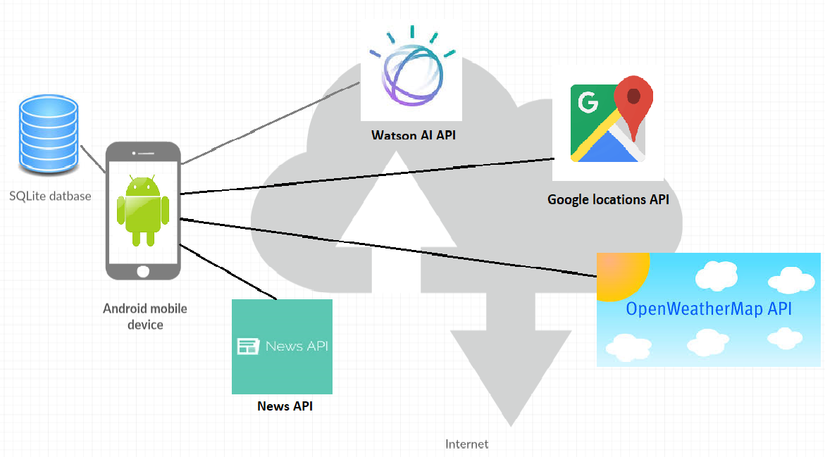

#### Architectural components of the distributed system:

* Android devices (e.g. Android phones and tablets).
* SQLite database
* Weather API:

<https://openweathermap.org/>

* News API:

<https://newsapi.org/>

* Google location API: <https://developers.google.com/android/reference/com/google/android/gms/location/FusedLocationProviderApi>
* Watson AI API:

<https://gateway.watsonplatform.net/natural-language-understanding/api>

<https://gateway.watsonplatform.net/personality-insights/api>

### System Design Diagram

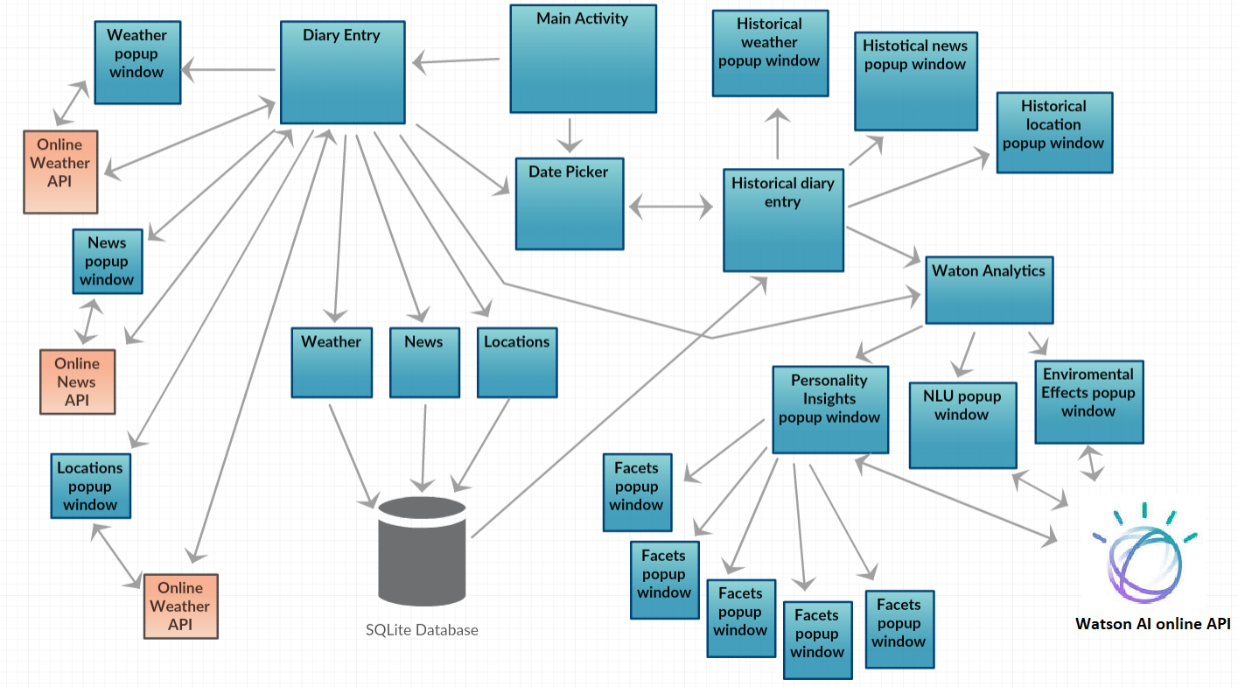

#### System design components

* Android activities and java classes
* SQLite database
* Weather API:

<https://openweathermap.org/>

* News API:

<https://newsapi.org/>

* Google location API: <https://developers.google.com/android/reference/com/google/android/gms/location/FusedLocationProviderApi>
* Watson AI API:

<https://gateway.watsonplatform.net/natural-language-understanding/api>

<https://gateway.watsonplatform.net/personality-insights/api>

## Implementation

### Class Diagram

Diagram of the main Java classes and functions used in the main source code.

**Note to reader:** The names of the some of the classes and functions in the diagram are not the exact spelling of the names and functions in the Java source code. They have been shortened or abstracted to fit all the most important information into the diagram for readability.

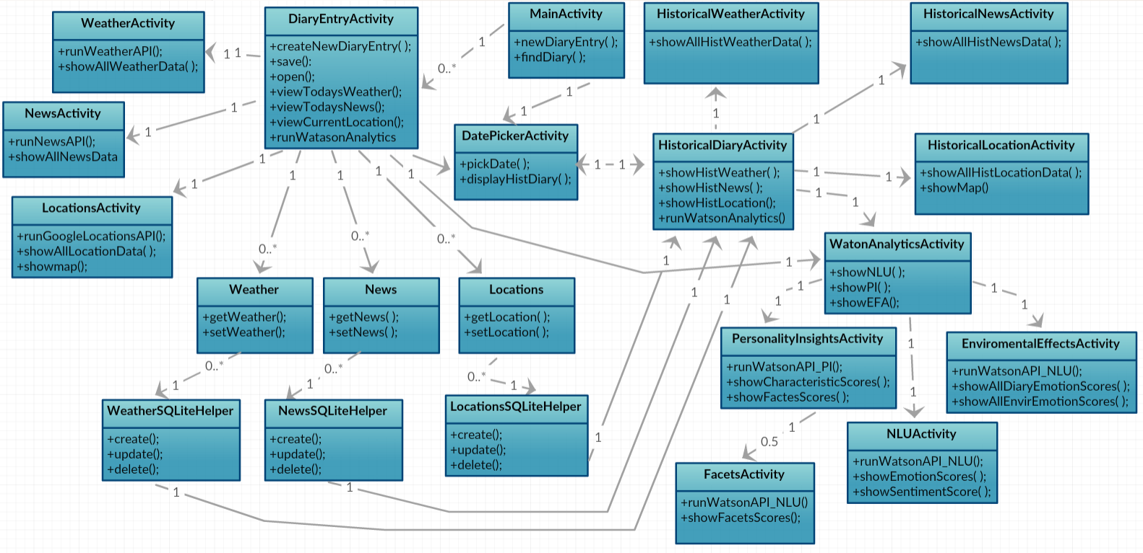

## Testing

### Clean and format code for testing

Cleaned and formatted all source code files and checked for orange warnings and red errors on code analysis sidebar.

**Checked all the java code for:**

Unused comments. Proper syntax format and spacing. Unused variables and functions. Checked for orange warnings and red errors in sidebar. Unused files.

**Checked all the xml code for:**

Unused comments. Proper syntax format and spacing. All text is using String resources. All text size is using ‘sp’ not ‘dp’. Deleted all invalid lines of code. Checked for orange warnings and red errors in sidebar. Unused files.

**Checked the drawable folder for:**

Unused images

**Checked the Gradle build code for:**

Proper syntax format and spacing. Checked all orange and red warnings.

### Testing activity

Created a testing activity for quick access to run the apps developer testing features. The testing activity can turn on/off all the testing dialogs on the app with the touch of a button. It can also clear all databases in the system with the touch of a button. As I am not using the video diary entry activity as Swapnil said it would take too much time. I shall use this activity for a testing activity. The testing activity can be accessed through the video diary entry button on the main activity.

### Testing dialogs

What are testing dialogs: testing dialogs popup to show data changes in the system when the developer is running an activity.

**Types of testing dialogs:**

* A dialog that popups up to show new rows inserted in the database.

Let’s the developer know instantly how many rows are in a database, so errors can be avoided, and time can be saved.

* A dialog that popups up to show a successful connection to an API (e.g. Watson).

Let’s the developer instantly know an API call is successful, so time is not wasted checking Android Monitor logs for unsuccessful remote server errors (e.g. HTTP UNAUTHORIZED: Status code 401).

* A dialog that popups up to show all the concatenated text data that is sent to a API for computing.

This is to make sure all the text data is formatted properly for the API. Poorly formatted text data may give inaccurate returned results.

* A dialog that popups up to show all the JSON data received for an API call.

This is to view all the JSON data in JSON format to know it has been received successfully, and to see the exact JSON data structure and content. Then the developer knows exactly what data they must work with and how it can be parsed.

### Reoccurring errors

When searching for errors in a class extending SQLiteOpenHelper class or a class that uses a class extending SQLiteOpenHelper, it is very easy to forget that one has not deleted the old database before trying to use a newly structured database. This was a common problem I found that wasted a lot of time with the same reoccurring type of errors. The solution was to create a button on the testing activity that deletes all databases, so this issue could be quickly tested.

## Graphical User Interface (GUI) Layout

### Wireframes

Wireframes from the design phase of the project:

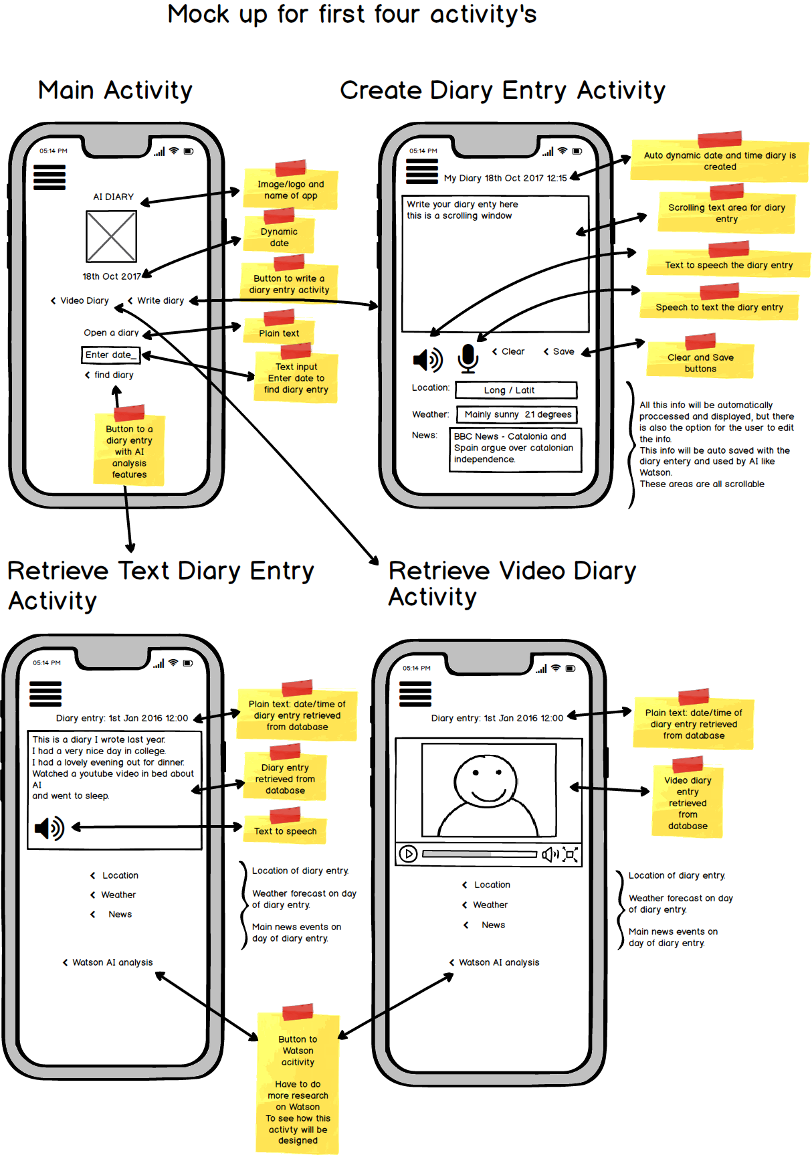

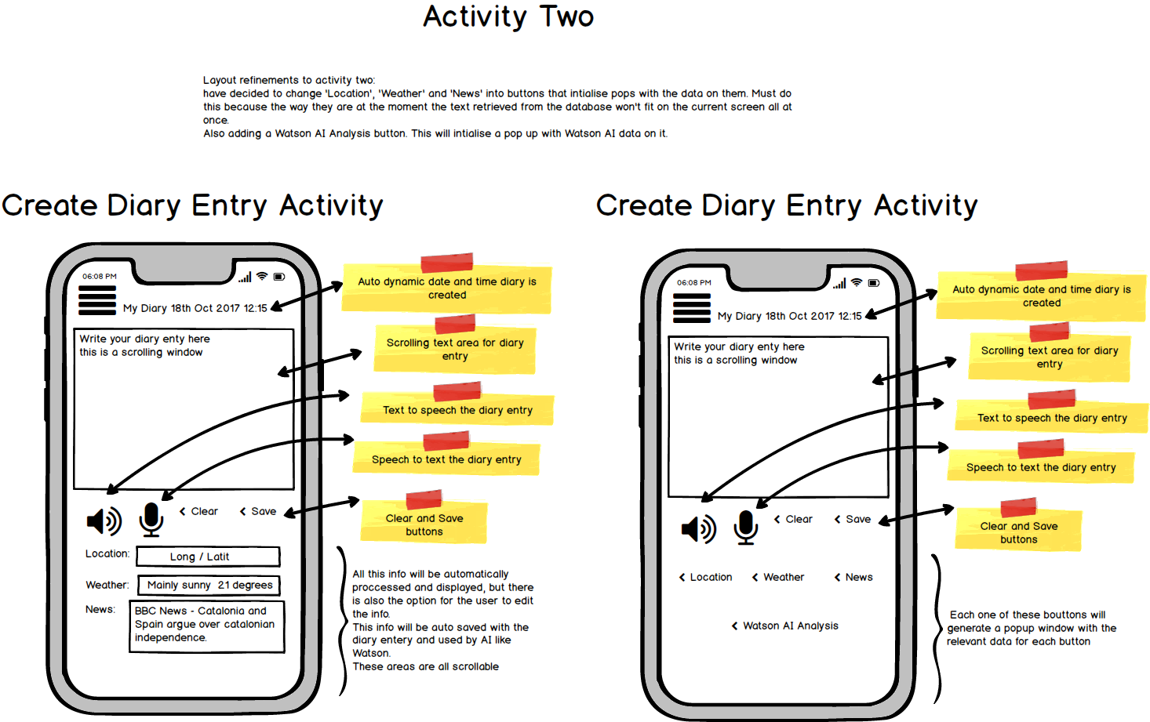

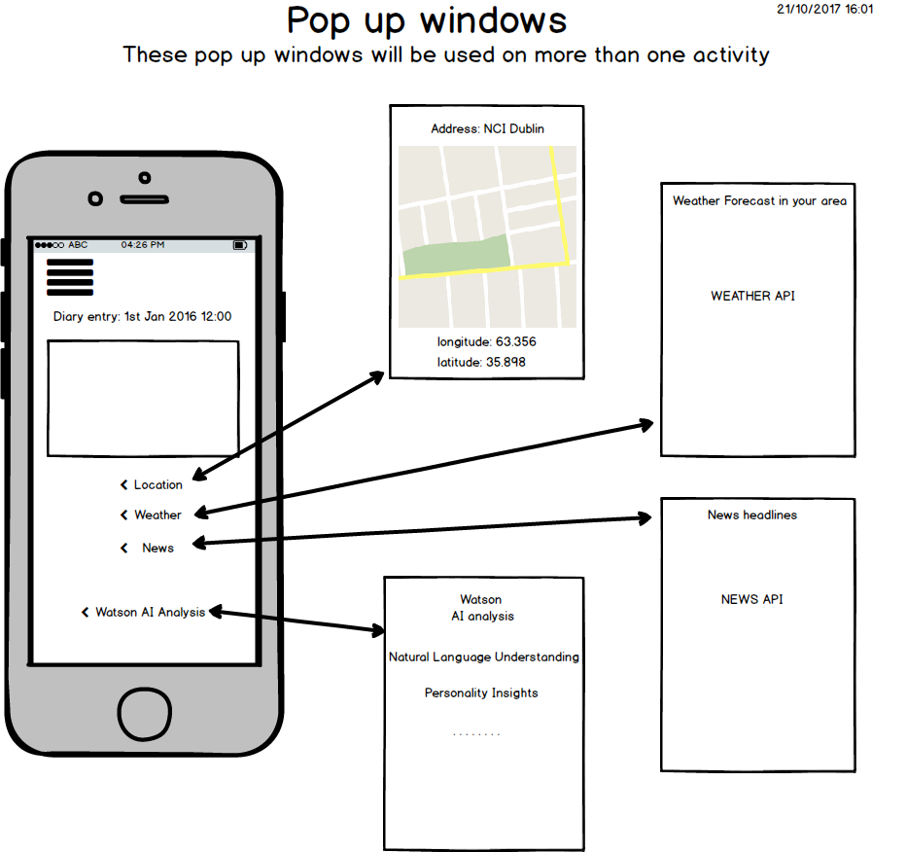

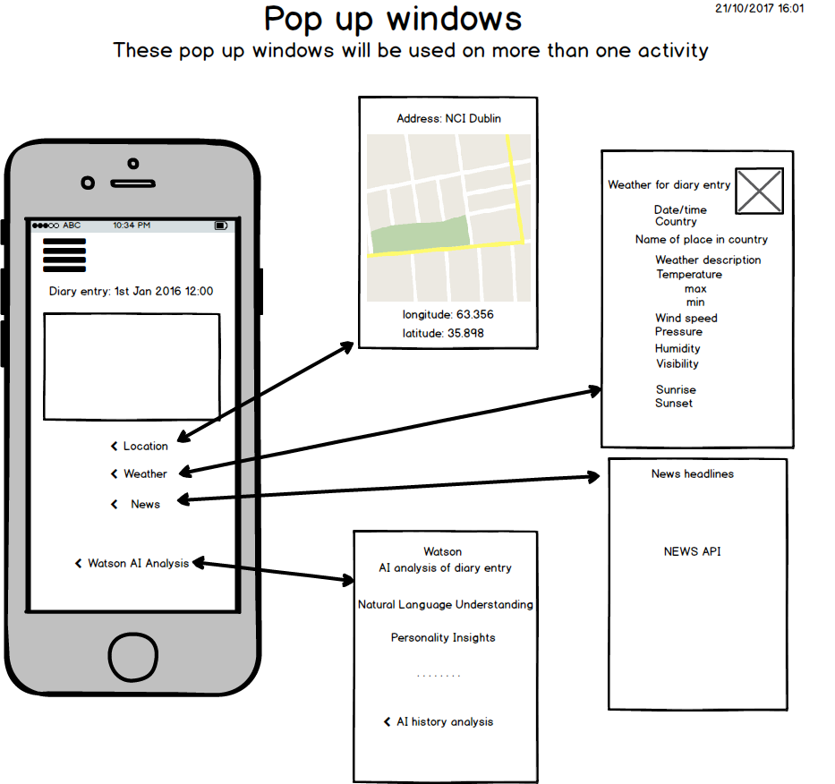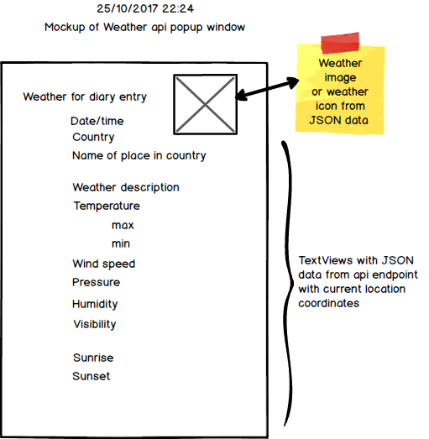

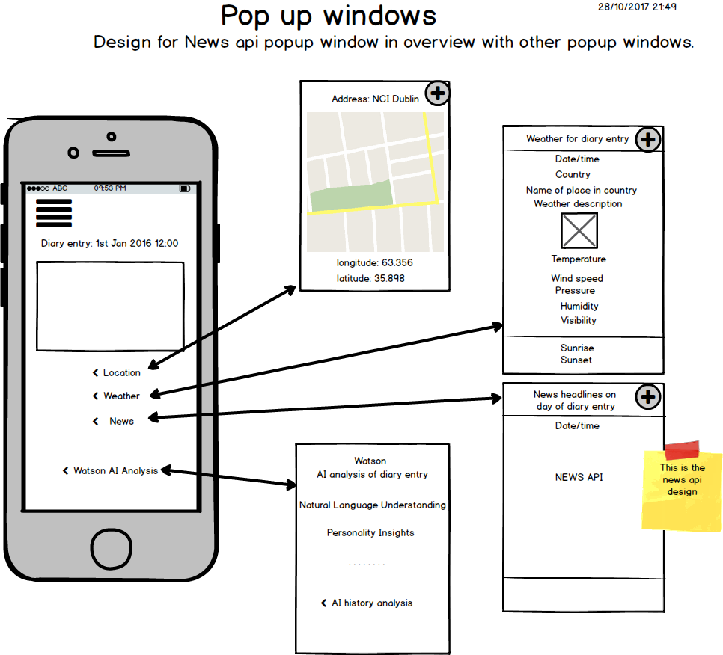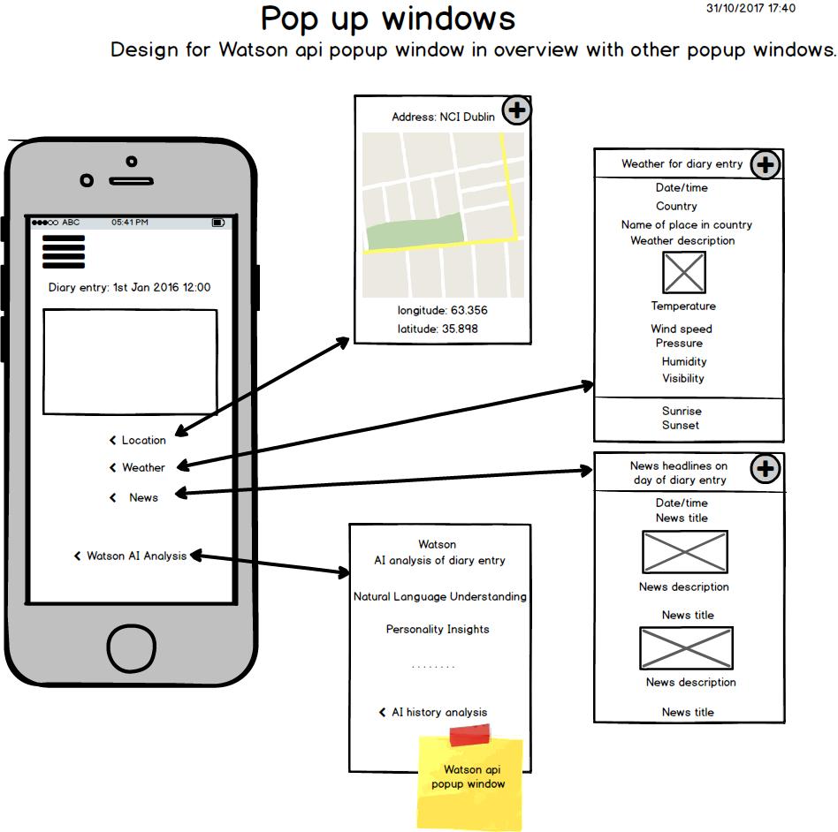

These wireframes were preliminary and were subject to feature changes. However, the main design structure conceptualised from these wireframes has remained the same throughout the project lifecycle.

### Screenshots of key screens and explanations.

#### Main activities

**Main Activity**

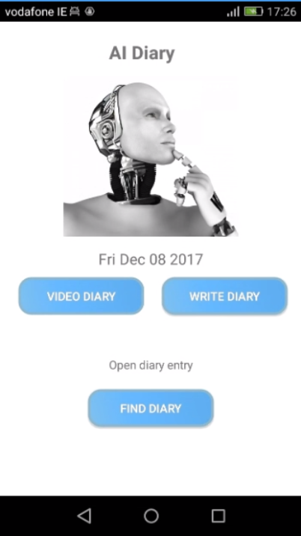

Press WRITE DIARY button in the **Main activity** and the following activity appears:

**Diary entry activity**

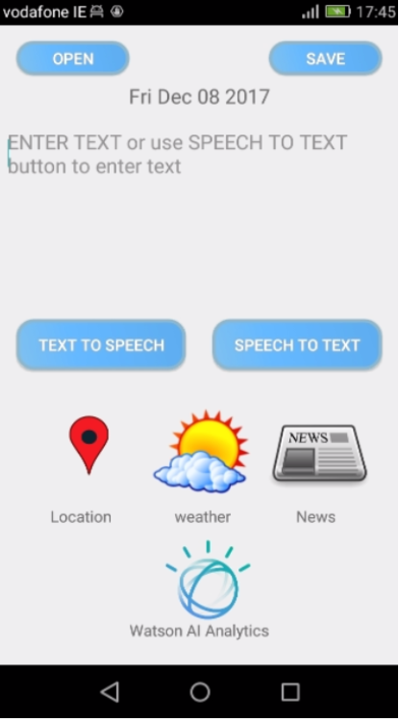

Fromthe **Diary entry activity** the user can write a diary for today and save it. Use speech to text or text to speech. Or view the locations, news, weather or Watson popup windows. Or the user can open an historical diary. When the user presses the OPEN button a datepicker will appear to choose a date for an historical diary entry. This date picker can also be accessed with the FIND DIARY button on the **Main activity**:

**Date picker activity**

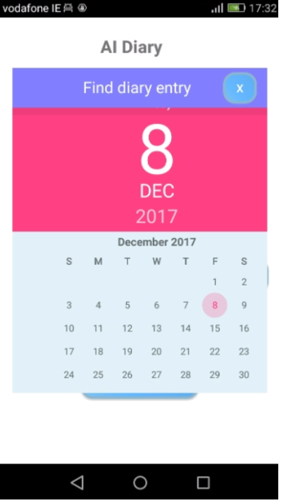

The user chooses a date to see an historical diary activity for that date if it exists (see below):

**Historical diary activity**

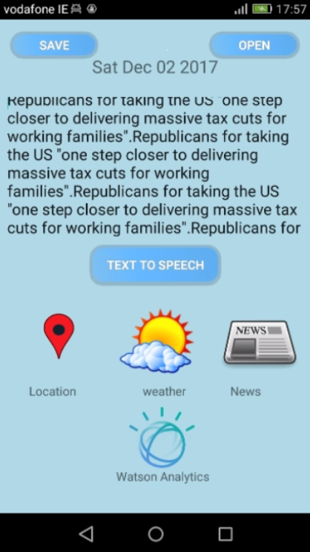

On the **Historical diary activity,** the user has all the same functionality as the **Diary entry activity** except for speech to text.

#### Sub activities

The following four screen shots show the weather, location, news and the Watson analytics popup window (with its further sub popup windows).

1. **Weather popup window activity**

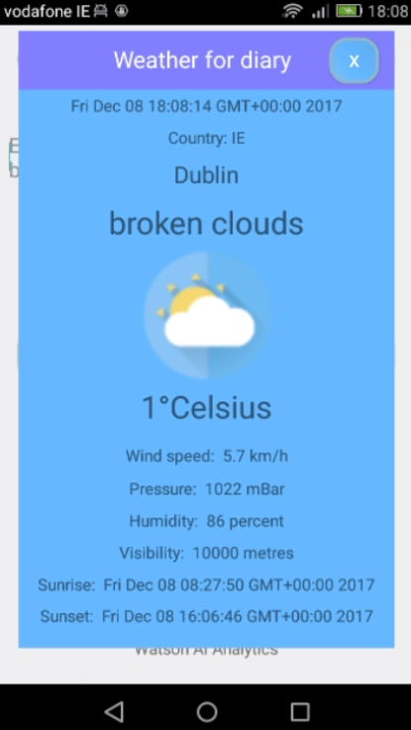

1. **Location popup window activity**

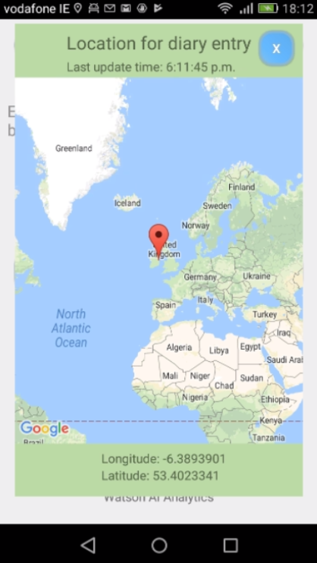

1. **News popup window activity**

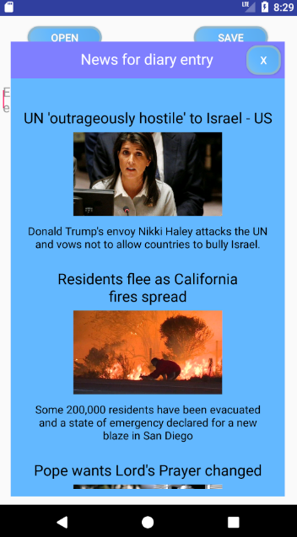

1. **Watson analytics activity**

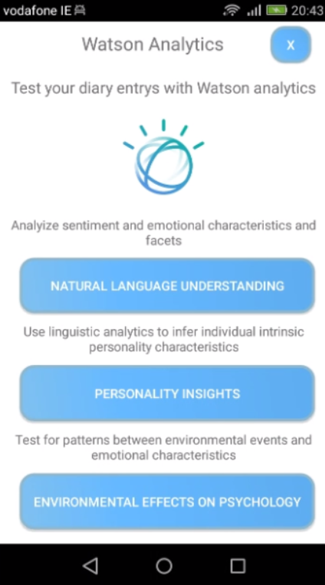

**Watson analytics activity** has three buttons each button opens a popup window activity that performs a service.

Here are the three popup windows:

**1. Natural Language Understanding popup window activity**

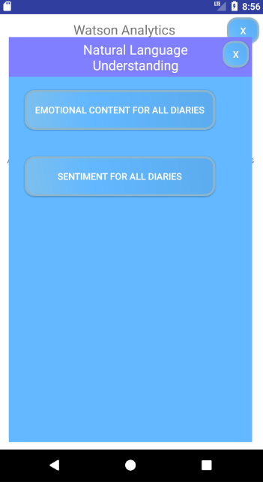 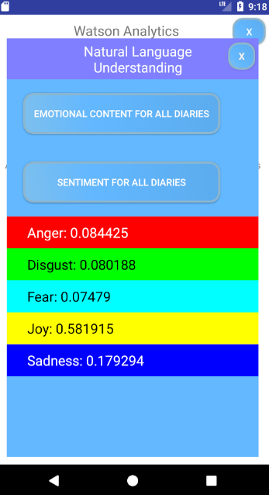 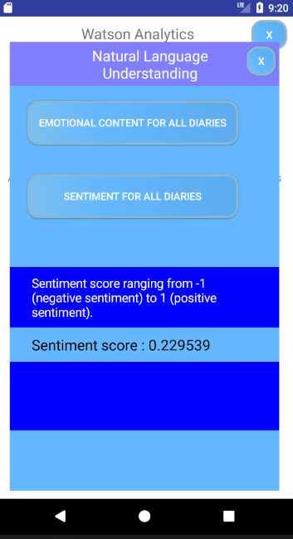

1st 2nd 3rd

When the EMOTIONAL CONTENT FOR ALL DIARIES button is pressed the five emotions and their scores for all diary entries appear in the empty space below the buttons (see 2nd screenshot above).

When the SENTIMENT FOR ALL DIARIES button is pressed the sentiment score appears for all diary entries in the empty space below the buttons (see 3rd screenshot above).

**2. Personality Insights popup window activity**

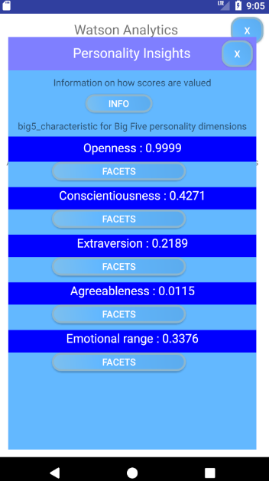 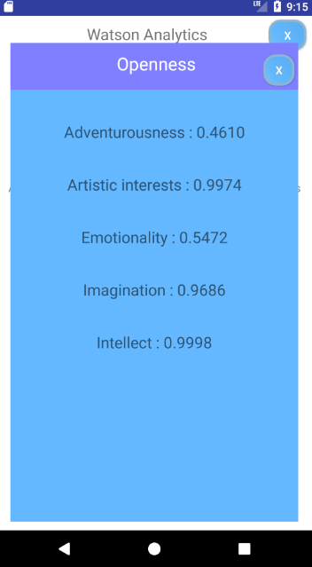

1st 2nd

When this activity is opened the five character traits are displayed with their scores for all diary entries (see 1st screen shot above). When a facets button is pressed for a character trait (also see 1st screen shot above) another popup window appears (see 2nd screen shot above) showing five characteristic facets with scores for that character trait above that button that was pressed.

**3. Environmental Effects on Psychology**

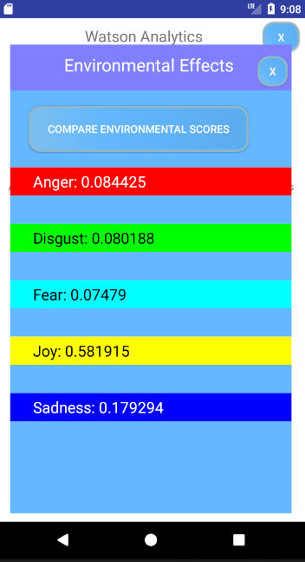 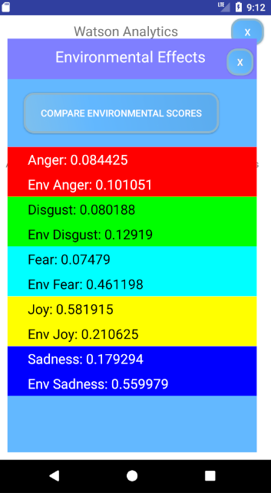

1st 2nd

When the COMPARE ENVIRONMENTAL SCORES button is pressed (see 1st screen shot above) the environmental scores appear underneath the diary entry scores which were already displayed on the activity when it opened. (see 2nd screen shot above).

## Customer testing

### Usability test.

The test Subject is Sarah Malone (35) from Dublin. I gave her little or no idea about the app only that it was a digital diary. I chose Sarah because she keeps a written diary. She also frequently likes to express her personal thoughts on Facebook and Twitter. I believe she would be somewhat representative of the target market or the persona that would use a digital diary. I reassured her that she wasn’t being tested and that there were no right or wrong answers to any questions asked. I tried not to ask any leading questions and let her freely use the app without any suggestions. I recorded our usability test and the following is a transcript of the main points made.

*(Main Activity)*

**Joe**: Sarah just use the app anyway you like.

**Sarah**: (*She looks a bit confused*) The name is a bit confusing ‘AI Diary’ what does All diary mean.

**Joe:** It’s not All Diary, its AI Diary, as in Artificial Intelligence Diary.

**Sarah:** Well I would change AI to A.I. so it’s not confusing, I thought it was trying to spell ALL.

**Joe:** O.K. good idea.

*(Sarah presses WRITE DIARY button on the Main Activity and goes to Diary Entry Activity)*

**Sarah:** *(Sarah comments about default text in diary entry text field)’* **ENTER TEXT or use SPEECH TO TEXT button to enter text’**, what does that mean?

**Joe:** Its telling you to enter text or use the SPEECH TO TEXT button.

**Sarah:** It’s a bit confusing, I wouldn’t put anything in there and I would put HEAR TEXT on that button (*she points to TEXT TO SPEECH button*).

**Joe:** O.K.

**Sarah:** (*Sarah uses speech to text and sees text appear on screen*) Hey that’s cool! (*Sarah then press TEXT TO SPEECH button to hear the text and is happily surprised to hear the voiced text)* but I would still call that button HEAR TEXT. (*Then she presses the news icon and opens the news popup window*). Can I get any news company?

**Joe:** No that’s the BBC News, maybe I’ll develop that at a later stage.

**Sarah:** O.k. no that’s good (*Sarah presses the weather icon and goes to the weather popup window).* I really like the that weather (*Then she closes the weather window and goes to the location popup window*). Hey this is really cool; can I move the map?

**Joe:** Yes.

**Sarah:** (*Sarah zooms in on the marker on the map*) Hey that’s really cool, there we are there. (*She points at the zoomed in marker location*) I really like that. (*She closes the location popup window and presses WATSON AI ANALYTICS button and opens Watson AI analytics activity. She spends some time reading the text above each button, and asks questions about Watson. I explain to her about Watson and how it can give emotional results and sentiment and environmental effects result).* Wow that’s interesting, you should patient that idea by sending yourself an email.

**Joe:** O.K. that’s a good idea, So, what do you think of the app?

**Sarah:** I really like the idea of being able to look back on my diaries from about five years ago and see how I was feeling and where I was. I had a lot of diaries from years ago that got lost, imagine I still had them now, if I had this app I couldn’t have lost them.

**Joe:** Yes, that’s true.

**Sarah:** How does Watson get the emotions?

**Joe:** It analyses all the diary text entries. People have been developing Watson for years. So, what do you think of the User Interface?

**Sarah:** Yes, that’s really good and easy to use, just take away that text in box, and change that button to HEAR TEXT.

**Joe:** So, do you think you would use the app.

**Sarah:** Yes definitely, it a very clever idea.

**Joe:** O.K thanks Sarah.

*End of interview.*

# Conclusions

## Coding with AsyncTask

(android.os.AsyncTask<Params, Progress, Result>)

It was only about half way through the main coding phase that I started understanding how to use AsyncTask. In the whole coding phase this class cost me more time than any other source code. The breakthrough came when I saw Swapnil using the AsyncTask as a private inner class. I would have never thought of this. I conclude from this and have learned from this that researching how a java class or section of code works saves time. Instead of spending too much time trying to work it out while coding.

## U.I. Design features

A lot of small features (e.g. button placement, icon placement) from the U.I. design phase has changed as the project developed. This can be seen when one looks back at the wireframes and compares them to the finished U.I.s. However, the main project U.I. design has stayed the same. I conclude from this that more time could have been given to the logical organisation of these smaller features on the U.I.s. before moving to the main coding phase.

## Testing

I think I should have given more time to the testing phase. Especially research about testing systems and procedures. I could have created more of my own testing features. I would have liked more time to create more buttons to run more testing process on the testing activity. I conclude from this, and have now learned that the testing phase is as important as any other phase in the project.

I would have also liked more time to test the app on people of different ages, especially young kids to see how they used the user interface. And a psychologist, to see what they had to say about the psychological analysis aspects of the app.

# Further Development or Research

## Video diary

I would like to develop the app to include a video diary entry activity. This activity would convert the voice of the video to text for Watson analysis. It would also be interesting to find an AI service that could analyse the user’s physical bodily movements for behavioural traits in the video diary. This could also be used for environmental effects analysis.

## Developing the app for collecting data for further research.

I want to put the app on Google Play for users to download. I would also like to further develop the app with an upload button. So, users can upload all their personal diary entries to a cloud service, where I can analyse demographic results. Results could be analysed for different countries, sexes, ages and times of the year etc.

## Further education

I would like to go further in education with research and development in A.I. cognitive computing and creative computing. I have contacted some academics researching in these areas and I would like to do a PhD, but have yet to get a reply. I am looking forward to the future and hope to get these opportunities for research and development in these areas, as I have really enjoyed working on this project.

# References

## Research links:

IBM Watson Natural Language Understanding Emotion Feature:

<https://www.ibm.com/watson/developercloud/natural-language-understanding/api/v1/#emotion>

IBM Watson Natural Language Understanding Sentiment Feature:

https://www.ibm.com/watson/developercloud/natural-language-understanding/api/v1/#sentiment

IBM Watson Personality Insights:

<https://www.ibm.com/watson/developercloud/personality-insights/api/v3/#introduction>

Personality insights Facets

<https://console.bluemix.net/docs/services/personality-insights/openness.html#openness>

<https://console.bluemix.net/docs/services/personality-insights/conscientiousness.html#conscientiousness>

<https://console.bluemix.net/docs/services/personality-insights/extraversion.html#extraversion>

<https://console.bluemix.net/docs/services/personality-insights/agreeableness.html#agreeableness>

<https://console.bluemix.net/docs/services/personality-insights/emotional-range.html#emotionalRange>

Watson Profile class:

<http://watson-developer-cloud.github.io/java-sdk/docs/java-sdk-3.9.1/com/ibm/watson/developer_cloud/personality_insights/v3/model/Profile.html>

Watson Trait class:

<http://watson-developer-cloud.github.io/java-sdk/docs/java-sdk-4.0.0/com/ibm/watson/developer_cloud/personality_insights/v3/model/Trait.html>

Swapnil’s tutorial links for connecting Java code to Bluemix services:

<https://console.bluemix.net/docs/services/natural-language-understanding/getting-started.html#getting-started-tutorial>

<https://www.ibm.com/watson/developercloud/natural-language-understanding/api/v1/?cm_mc_uid=44406559295315085991054&cm_mc_sid_50200000=1508599105&cm_mc_sid_52640000=1508601172#introduction>

<https://cloud.google.com/appengine/docs/standard/java/quickstart-java8>

Weather API:

<https://openweathermap.org/>

News API:

<https://newsapi.org/>

How to get data from the News Api:

<https://www.youtube.com/watch?v=_SAEd7TIPkA>

Google location API: <https://developers.google.com/android/reference/com/google/android/gms/location/FusedLocationProviderApi>

Deepmind’s AlphaGo

[https://deepmind.com/research/alphago/](https://deepmind.com/research/alphago/%20(https://deepmind.com/research/dqn/)

DQN

<https://deepmind.com/research/dqn/>

DNC

<https://deepmind.com/research/dnc/>

How to set an event listener on the datepicker when a date is picked:  
<https://stackoverflow.com/questions/2051153/android-ondatechangedlistener-how-do-you-set-this>

IBM What’s next for AI:

<https://www.ibm.com/watson/advantage-reports/future-of-artificial-intelligence/ai-innovation-equation.html>

Get todays date:

<https://stackoverflow.com/questions/5046771/how-to-get-todays-date>

Get day month and year separately using SimpleDateFormat:

<https://stackoverflow.com/questions/22989840/get-day-month-and-year-separately-using-simpledateformat>

Convert epoch time (epoch is the number of seconds since Jan 1, 1970. Data from JSON) to human readable time, so **Sunrise** and **Sunset** on weather popup would not be displayed as long epoch numbers: <https://stackoverflow.com/questions/535004/unix-epoch-time-to-java-date-object>

Using Linear and Relative layout: <https://www.youtube.com/watch?v=evaFGWURAS4>

How to initialise an event from selecting a date on the date picker:

<https://stackoverflow.com/questions/2051153/android-ondatechangedlistener-how-do-you-set-this>

Receiving location updates:

<https://developer.android.com/training/location/receive-location-updates.html>

Using Google map marker:

<https://stackoverflow.com/questions/24737146/update-position-of-a-marker-without-adding-a-new-one> <https://developers.google.com/maps/documentation/android-api/marker>

How to parse JSON:

<https://stackoverflow.com/questions/17136769/how-to-parse-jsonarray-in-android>

Using Glide to load images:

<https://inthecheesefactory.com/blog/get-to-know-glide-recommended-by-google/en>

**Balsamiq** used for creating mock-ups:

[https://balsamiq.com/download/#](https://balsamiq.com/download/)

Project plan created with Smartsheet.com: <https://www.smartsheet.com/gantt-chart-software>

## Researched literature:

**Oxford Dictionary of Psychology**

by Andrew M. Colman, published 2008,

**ISBN-13**: 9780199534067

**The Essentials of Psycho-Analysis**

by Sigmund Freud, published 3rd January 2008,

**ISBN** 9780099483649

**The Archetypes and the Collective Unconscious**

by Carl Gustav Jung,published 6th June 1991

**ISBN** 9780415058445

Research literature and internet on AI and Cognitive computing.

**Cognitive Computing: A Brief Guide for Game Changers**

by Peter Fingar, published December 2, 2014,

**ISBN-10:** 0929652517

**ISBN-13:** 978-0929652511

**Surviving AI: The Promise and Peril of Artificial Intelligence**

by Calum Chace, published July 2015,

**ISBN-13:** 978-0993211621.

## Project images:

Cover and app Main activity image taken from:

<https://phrasee.co/what-is-artificial-intelligence/>

Watson app icon image:

<https://en.wikipedia.org/wiki/Watson_(computer)#/media/File:IBM_Watson_Logo_2017.png>

Weather popup window, weather description icon images:

<https://dribbble.com/shots/2191392-Free-weather-flat-icons>

App location marker button icon image:

<https://publicdomainvectors.org/en/search/location-png>

App weather button icon image:

<https://commons.wikimedia.org/w/index.php?title=Special:Search&limit=20&offset=80&profile=default&search=+weather+icon+png&searchToken=7zpjqk1oyl23fmam3grver956>

App news button icon image:

<https://publicdomainvectors.org/en/free-clipart/Internet-news-reader-icon-vector-illustration/14724.html>

# Appendix

## Project Proposal

Project Proposal

**AI. DIARY**

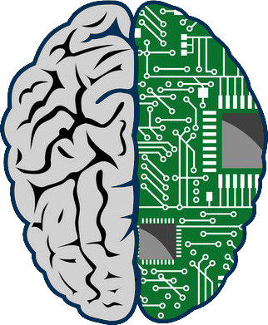

Joe Fanning, x16112415, joespirial@hotmail.com

Higher Diploma in Science in Computing (HDMAICTJAN)

Specializing in Mobile Technologies.

1st Oct 2017

Objectives

This project will be open source.

The main objective of this project is to collect data to aid in the development of (AGI) artificial general intelligence, especially in area of cognitive computing.

The data will be personal thoughts of numerous individuals collected over the next ten years.

The data will be collected using an app called AI. Diary. The app will function as an everyday personal digital diary. The app will use IBM Bluemix AI. services to make the app more user friendly.

All data from every downloaded app will be uploaded to a cloud server for the projects research and development over the next ten years.

Participants downloading the app will agree to all their diary entries being used in this project.

The app will have automated daily routines. Such routines will automatically record the date time of every diary entry, the location of every diary entry, the local and national weather forecast at date/time of every diary entry, major news event/events of each day.

All routine data will be used in correlation with diary entries data to study environmental stimulus on human psychology.

Data collected over the years can be sold to big companies like Google, IBM or Microsoft or used to create a research lab from this project.

Problem: what intensive to use get people to share personal every day thoughts

(Max. 1 Page)

Background

With the new Spring of AI. there is a burst of ongoing development around the world in computer science to develop more human like computers and general AI. Computing speed has always been important, but it seems as much now about replicating all diverse types of human brain and mind functions and behaviors. IBM Watson’s(https://commonweal/watson/products-services/) *Natural Language Understanding*, *Conversation* and *Personality* *Insights or Deepmind’s AlphaGo(https://deepmind.com/research/alphago/), DQN(https://deepmind.com/research/dqn/) and DNC(https://deepmind.com/research/dnc/)* are just a few examples. The development of AI. seems to be moving at a growing pace and is having a very positive effect on the world today.

Figure 1. IBM Website page. Article heading: ‘What’s next for AI’

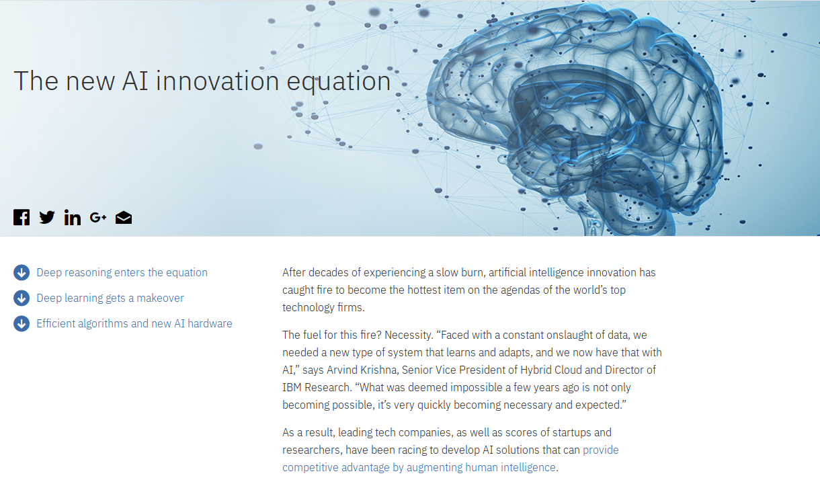

Web page link:

<https://www.ibm.com/watson/advantage-reports/future-of-artificial-intelligence/ai-innovation-equation.html>

Where will all this lead to?

It will inevitably lead to the creation of a computer brain that mimics a human brain.

To develop an artificial computer brain with the same capabilities as a human brain would probably mark the beginning of a very positive new era in computing.

And can I help in any way?

If or when this brain is created it will have to be able to think for itself, learn on it’s own (Deep Learning). It will have to have unconscious process just like a human brain and mind.

When we learn on our own we individually collect information in our brain and process it and unconscious process work in the background. This could be analogous to a daemon process in a computer.

Every brain is different, every brain has and is experiencing a different life and sequence of events.

So every brain process and mind experience in an individual is in some way is a different conscious and unconscious experience than every other individual.

What better way to understand these process or experiences than to collect numerous personal human thought processes and experiences from individual personal diaries.

The AI. Diary app would do this.

The background idea of this project is to help gather information (data) that will hopefully aid in some way with the worldwide endeavor to create artificial intelligence. It would be very exciting to play some part in the process of collecting this data for future research and development.

(Max. 2 Pages)

Technical Approach

Research literature and internet on Freudian and Jungian psychology for a deeper understanding of psychology and how it is applied to AI (e.g. nomenclature like cognitive in cognitive computing).

Research literature and internet on AI. and Cognitive computing.

Study IBM Bluemix Platform (PaaS).

Research IBM Bluemix documentation about services. Study Bluemix Platform.

Integrate IBM Bluemix services with Android Studio for creation of app.

Brief description of the approach to be followed (Max. 1 Page), Research, literature review, requirements capture, implementation etc.

Special resources required

Research literature and internet on Freudian and Jungian psychology for a deeper understanding concepts like cognitive computing.

**Oxford Dictionary of Psychology**

by Andrew M. Colman, published 2008,

**ISBN-13**: 9780199534067

**The Essentials of Psycho-Analysis**

by Sigmund Freud, published 3rd January 2008,

**ISBN** 9780099483649

**The Archetypes and the Collective Unconscious**

by Carl Gustav Jung,published 6th June 1991

**ISBN** 9780415058445

Research literature and internet on AI. and Cognitive computing.

**Cognitive Computing: A Brief Guide for Game Changers**

by Peter Fingar, published December 2, 2014, **ISBN-10:** 0929652517 **ISBN-13:** 978- 0929652511

**Surviving AI: The Promise and Peril of Artificial Intelligence**

by Calum Chace, published July 2015, **ISBN-13:** 978-0993211621.

Online cloud resource

<https://www.ibm.com/cloud-computing/bluemix>

Hardware

Phone

If applicable, e.g., books, hardware, etc.

Project Plan

|  |  |  |
| --- | --- | --- |
| Week 1 | Research literature and internet for concepts for a project. |  |
| Week 2 | Define project plan and proposal |  |
| Week 3 | Gather requirement specification.  (Research IBM Bluemix mobile, research literature on AI., cognitive computing, Jungian and Freudian psychology.  Upload project plan and proposal (deadline Sun 8th Oct). | Upload deadline Sun 8th October |
| Week 4 | UML and wire frames  Gather requirement specification. |  |
| Week 5 | Research Java code/docs to use in app for different functionalities an U. Is.  Integrate IBM Bluemix mobile with Android Studio. |  |
| Week 6 | Project analysis and design  Project main build of source code on Android Studio and integration with Bluemix mobile services. |  |
| Week 7 | Project main build of source code on Android Studio and integration with Bluemix mobile services. |  |
| Week 8 | Project test plan  Test source code  Test app U.I. with users. |  |
| Week 9 | Final fix of source code and Bluemix integration with app. |  |
| Week 10 | Prepare presentation of project documentation for upload. |  |
| Week 11 | Upload app to Google Play  Final software and documentation upload  (deadline 30th Nov) | Upload deadline 30th November |
| Week 12 | Prepare PowerPoint presentation for project class presentation.  Project presentation | To be confirmed |
| Week 13 | Project presentation | To be confirmed |

Gantt chart using Microsoft Project or similar tool with details on implementation steps and timelines

Technical Details

Java Language (Java 8),

Java online documentation

Android software and hardware

Android Studio version 2.3

Android SDK tool 26.0.2

Android platform version 8.0 (O) revision 1

Device testing will be carried out with:

Huawei SCL -L01. Android version 5.1.1 (Phone version to be updated for project)

Android emulator (Nexus 5X)

Google Play Services

IBM Bluemix

Platform:

Mobile services:

App ID

Push Notifications

Mobile Foundation

Watson services:

Speech to Text

Natural Language Understanding

Personal Insights

Discovery

Data and Analytics:

Cloudant NoSQL DB

Implementation language and principal libraries

Evaluation

Test the app in phases of development with usability tests on different users.

Device testing will be carried out with:

Huawei SCL -L01. Android version 5.1.1 (Phone version to be updated)

Android emulator (Nexus 5X)

Describe how you will evaluate the system with real technical data using system tests, integration tests etc. In addition, where possible describe how you will evaluate the system with an end user.

cover image taken from: <http://hits1k.com/>

*end of Project Proposal document*

## Project Plan

### Project plan with Gannt chart

Note to reader: The Project Plan with Gannt chart below has been split into three sections for readability. As one single image would leave the print too small to read.

**Project Plan with Gannt chart**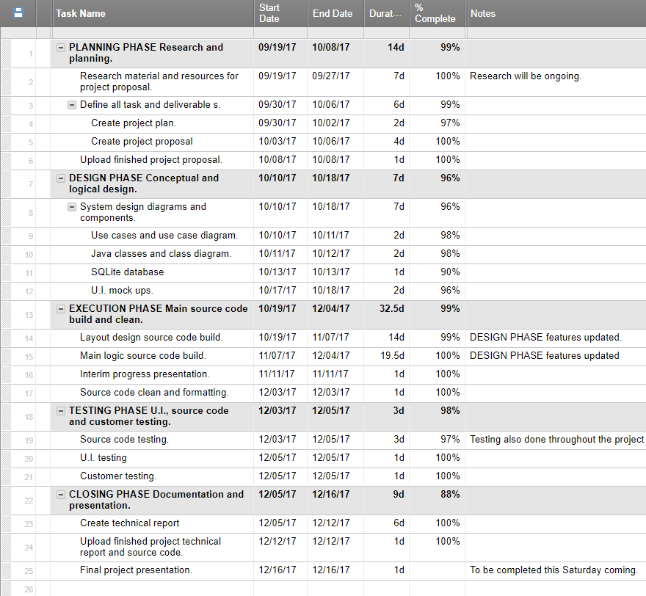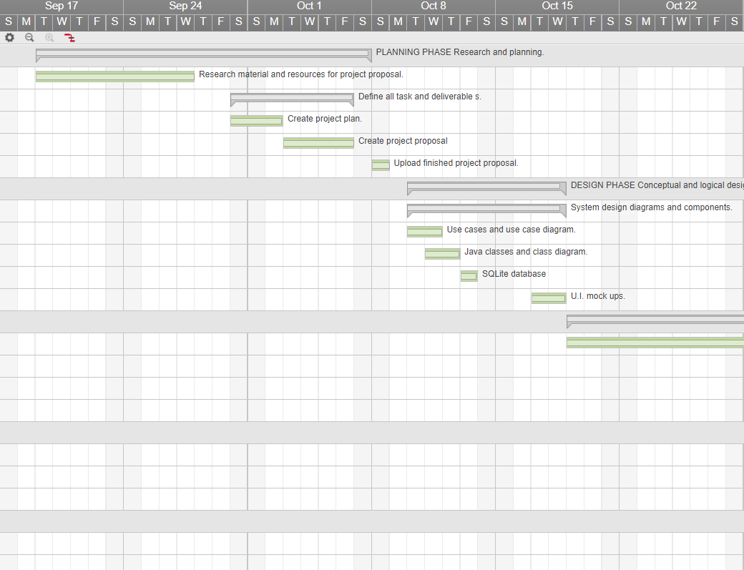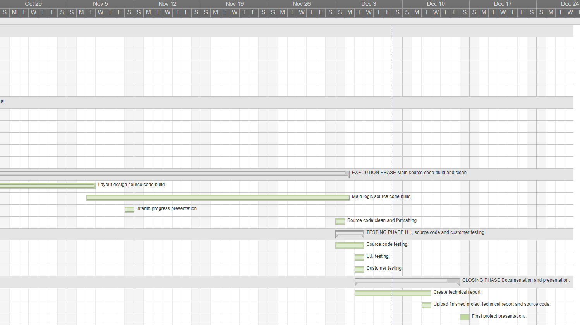

## Monthly Journals

Please see all the following daily journal files attached in the same folder with this Project Technical Report pdf document.

### October daily journals



### November daily journals



### December daily journals



End of document